EXPERIMENT: 13

**Title: To understand the concepts of PL/SQL programming.**

1. Write a PL/SQL code to accept the value of A, B & C display which is greater

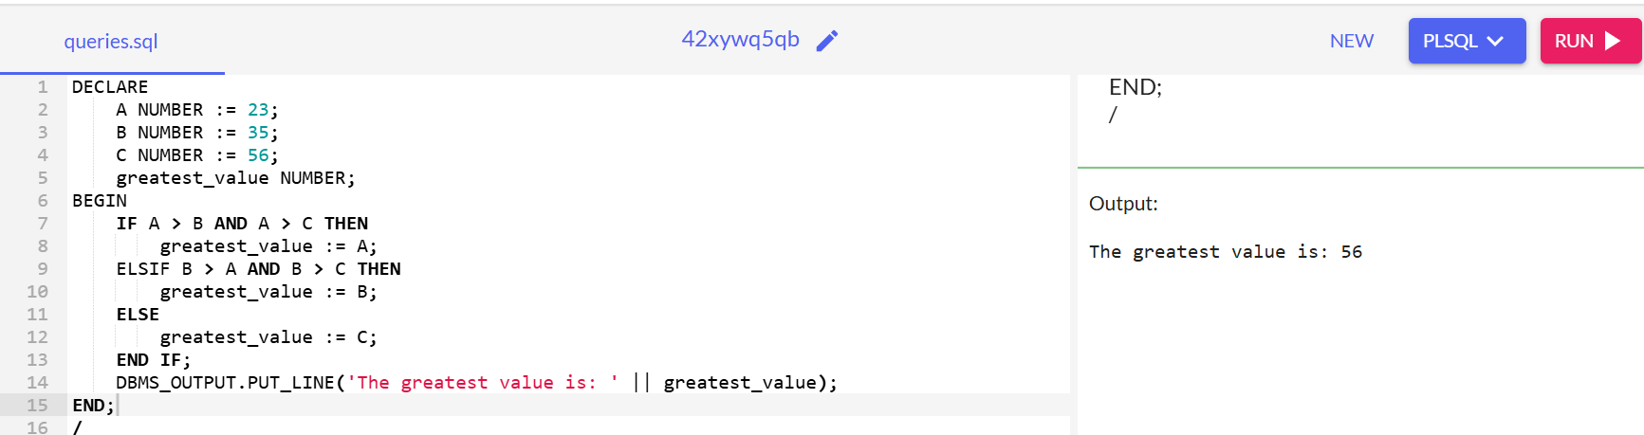

1. Using PL/SQL Statements create a simple loop that display message “Welcome to PL/SQL Programming” 20 times.

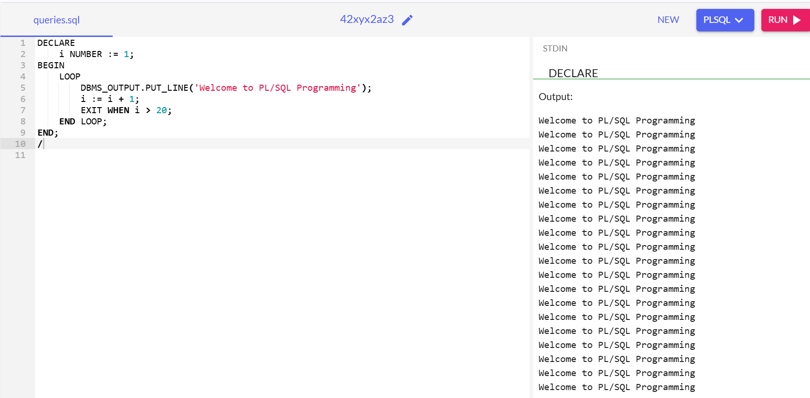

1. Write a PL/SQL code block to find the factorial of a number

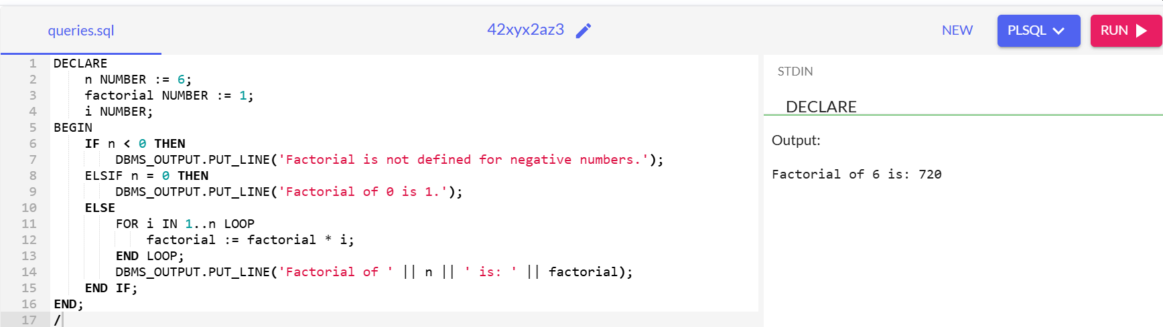

1. Write a PL/SQL program to generate Fibonacci series.

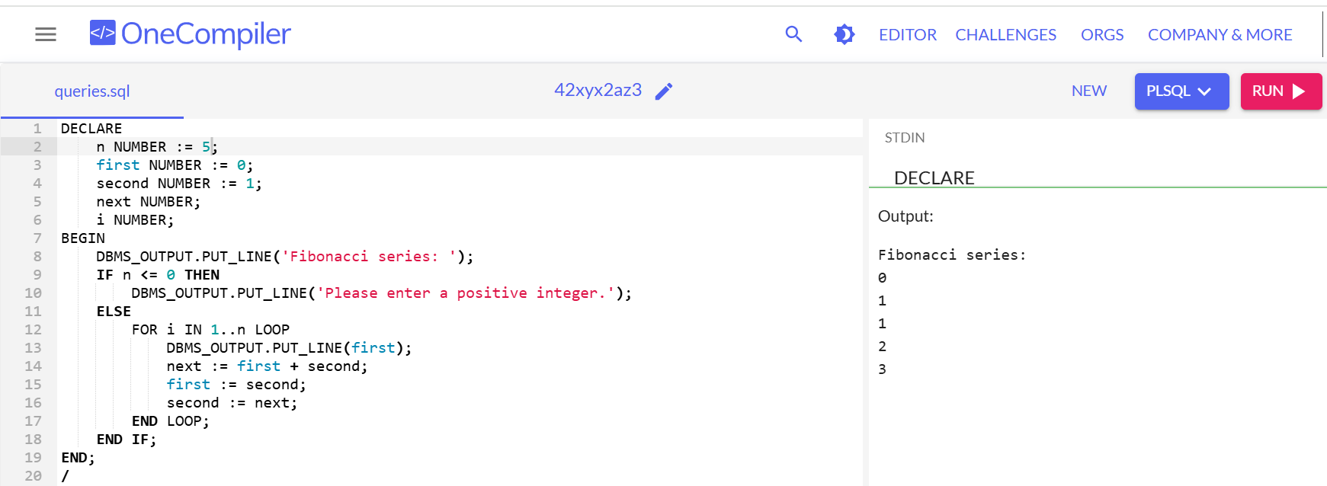

1. Write a PL/SQL code to fund the sum of first N numbers

